
Tertiary Infotech Academy Pte Ltd
UEN: 201200696W
LESSON PLAN
For
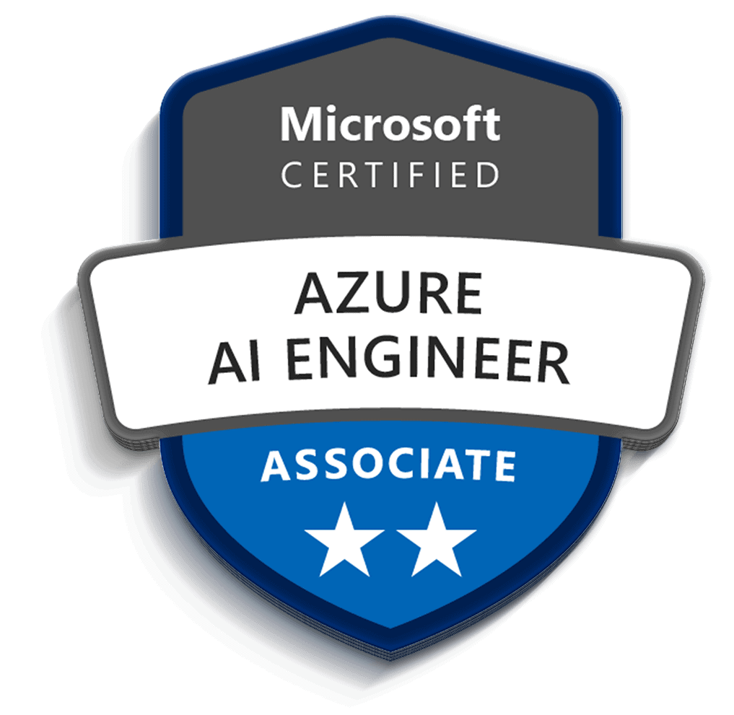
Microsoft Certified Azure AI Engineer Associate AI-102 Training
TGS Ref No: TGS-2023036651
Version 1.0

DOCUMENT VERSION CONTROL RECORD
Version Number | Effective Date of Release | Summary of Included Changes | Author
1.0 | 8 July 2026 | First version aligned to the generated PPT slide numbers and 10 AI-102 labs. | Tertiary Infotech Academy Pte Ltd

TABLE OF CONTENTS
Document Version Control Record 2
Table of Contents 3
Course Information 4
Lesson Schedule with Slide Numbers 4
Labs Covered 5
Assessment Notes 6

Course Information
Course Title | Microsoft Certified Azure AI Engineer Associate AI-102 Training
Course Code | TGS-2023036651
TSC Title | Artificial Intelligence Application in Product Development
TSC Code | ICT-TEM-4034-1.1
Duration | 2 Days (16 training hours)
Daily Schedule | 9:00 AM - 6:00 PM, including lunch and tea breaks
Delivery Mode | Instructor-led, hands-on labs and guided design activities
Assessment | Day 2 final assessment from 4:00 PM

Lesson Schedule with Slide Numbers
Time | Topic / Activity | Duration | Slides
Day 1 9:00-9:20 | Digital attendance, trainer/learner introduction, ground rules | 20 min | 1-15
Day 1 9:20-10:20 | Lab 01 - Plan, manage, monitor, and secure an Azure AI solution | 60 min | 17-21
Day 1 10:20-10:35 | Tea break | 15 min | -
Day 1 10:35-11:35 | Lab 02 - Responsible AI, content safety, governance | 60 min | 22-26
Day 1 11:35-12:35 | Lab 03 - Generative AI, Foundry, Azure OpenAI, prompt flow, RAG | 60 min | 27-31
Day 1 12:35-1:00 | Review and Q&A | 25 min | 27-31
Day 1 1:00-2:00 | Lunch break | 60 min | -
Day 1 2:00-3:00 | Lab 04 - Agentic AI, Foundry Agent Service, multi-agent concepts | 60 min | 32-36
Day 1 3:00-4:00 | Lab 05 - Computer Vision, Custom Vision, video insights | 60 min | 37-41
Day 1 4:00-4:15 | Tea break | 15 min | -
Day 1 4:15-5:35 | Lab 06 - NLP, Language, Speech, Translation | 80 min | 42-46
Day 1 5:35-6:00 | Day 1 recap and checkpoint questions | 25 min | 42-46
Day 2 9:00-9:15 | Digital attendance and Day 1 recap | 15 min | 47
Day 2 9:15-10:15 | Lab 07 - Custom Language Models and Question Answering | 60 min | 48-52
Day 2 10:15-10:30 | Tea break | 15 min | -
Day 2 10:30-11:45 | Lab 08 - Azure AI Search, knowledge mining, vector search | 75 min | 53-57
Day 2 11:45-1:00 | Lab 09 - Document Intelligence and Content Understanding | 75 min | 58-62
Day 2 1:00-2:00 | Lunch break | 60 min | -
Day 2 2:00-3:30 | Lab 10 - AI-102 capstone and course review | 90 min | 63-67
Day 2 3:30-4:00 | Assessment briefing and review | 30 min | 12-13
Day 2 4:00-5:15 | Final assessment | 75 min | 12
Day 2 5:15-5:30 | Tea break | 15 min | -
Day 2 5:30-6:00 | TRAQOM, support, closing | 30 min | 68-73

Labs Covered
Lab | Main Topic | Title | PPT Slides
01 | Planning and operations | Plan, Manage, Monitor, and Secure an Azure AI Solution | 17-21
02 | Responsible AI | Responsible AI, Content Safety, Governance | 22-26
03 | Generative AI | Generative AI, Foundry, Azure OpenAI, Prompt Flow, RAG | 27-31
04 | Agents | Agentic AI, Foundry Agent Service, Multi-Agent Concepts | 32-36
05 | Vision | Computer Vision, Custom Vision, Video Insights | 37-41
06 | Language and speech | NLP, Language, Speech, Translation | 42-46
07 | Custom language | Custom Language Models and Question Answering | 48-52
08 | Search and mining | Azure AI Search, Knowledge Mining, Vector Search | 53-57
09 | Document AI | Document Intelligence and Content Understanding | 58-62
10 | Integrated review | AI-102 Capstone and Course Review | 63-67

Assessment Notes
- Ensure AM, PM and Assessment digital attendance are completed.
- Assessment is open book using approved materials: slides and Learner Guide.
- Learners must complete assessment activities and be assessed as Competent for funding eligibility.

